**Derby Database**:

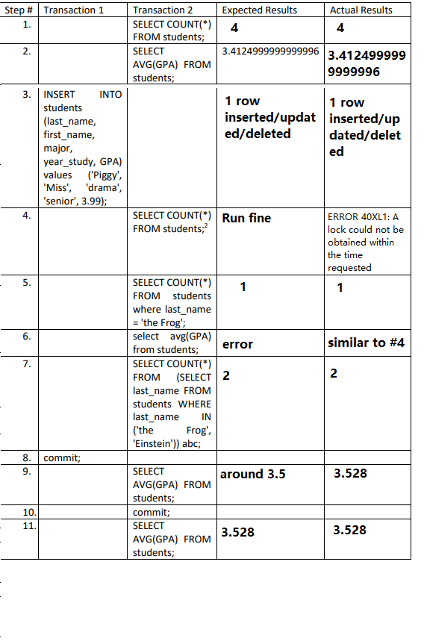

**MySQL:**

|  |  |  |  |  |
| --- | --- | --- | --- | --- |
| Step # | Transaction 1 | Transaction 2 | Expected Results | Actual Results |
| 1. | START  TRANSACTION; |  | No errors. | START Transaction (0 rows affected) |
| 2. |  | START  TRANSACTION; | No errors. | START Transaction (0 rows affected) |
| 3. |  | SELECT AVG(GPA)  FROM students; | Return the avg gpa of all students. | 3.412500023841858 |
| 4. |  | SELECT COUNT(*)  FROM students; | 4 | 4 |
| 5. | INSERT INTO students (last_name, first_name, major, year_study, GPA) values ('Piggy', 'Miss', 'drama', 'senior', 3.99); |  | No errors. | INSERT INTO students (1 row affected) |
| 6. |  | SELECT COUNT(*) FROM students; | 5 | 4 |
| 7. |  | SELECT COUNT(*) FROM students WHERE last_name = 'the Frog'; | 1 | 1 |
| 8. |  | SELECT AVG(GPA) FROM students; | 3.412500023841858 | 3.412500023841858 |
| 9. |  | SELECT COUNT(*) FROM (SELECT last_name FROM students WHERE last_name IN ('the Frog', CECS 323 Lab Transactions.docx 1/18/2021 7:35:00 PM 5 CECS 323 LAB TRANSACTIONS 'Washington')) abc; | 2 | 2 |
| 10. | COMMIT; |  | No errors. | No errors. |
| 11. |  | SELECT AVG(GPA) FROM students; | 3.412500023841858 | 3.412500023841858 |
| 12. |  | COMMIT; | No errors. | No errors. |
| 13. |  | SELECT AVG(GPA) FROM students; | 3.412500023841858 | 3.528000020980835 |